# TIBCO Business works Interview Questions



**What is the critical section in TIBCO Business works and what is it used for?**

Critical section is used to sync process instances so that only once process instance executes the grouped activities at any given time. Any concurrently running process instances that contain a corresponding critical section group wait until the process instance that is currently executing the critical section group completes. Particularly used for controlling access to shared variables. Critical section is one of the group actions. Others are iterating, repeat until true, repeat on error until true, while true, pick first and transaction. If we select critical section as the group, then we get two options. Single group and multiple groups.

**Single Group**

If you wish to synchronize process instances for a single process definition in a single process engine (only one ear(instance) is deployed), perform the following:

* Create a group around the activities you wish to synchronize.
* Specify Critical Section for the Group Action field.
* Specify Single Group for the Scope field.
* Only one process instance at any given time will execute the activities contained in the Critical Section group.

**Multiple Groups**

If you wish to synchronize process instances for multiple process definitions, or if you wish to synchronize process instances across multiple process engines, perform the following:

* Create a Lock shared configuration resource and specify a name for the resource.
* To perform the synchronization across multiple process engines, check the Multi-Engine field of the Lock resource. When the process instances are executed by the same process engine, locking is performed in memory. When the process instances are executed across multiple engines, the process engines must be configured to use a database for storage, and a database transaction is performed to ensure that only one process instance is executing the critical section group at any given time.
* Create a group around the activities you wish to synchronize.
* Specify Critical Section for the Group Action Field.
* Specify Multiple Groups for the Scope field.
* Use the Browse button in the Lock Object field to locate the Lock shared configuration resource you created in Step 1.
* Perform steps 3 to 6 for any process definitions you wish to synchronize. Make sure you specify the same Lock shared configuration object for all Critical Section groups.

|  |
| --- |
|  |

[](https://www.gologica.com/course/tibco-business-workds/)

**If there are three activities in the critical section, jdbc update then a write file and then again jdbc update. If the second jdbc update fails, then what will happen to the file written by write file activity?**

The contents of the file will persist.

**What are different types of transaction groups supported in TIBCO BW?**

Iterate, repeat until true, repeat on error until true, critical section, transaction, pick first, while true.

**Can two queue receivers listen to the same queue? If yes, if the message arrives on the queue, when receiver receives it?**

The queue which has made connection first. First come first serve.

**If the message has hit the queue, and there are no receivers for it, and the receiver comes alive after 6 hours, what happens to the message?**

Message stays on the queue.

**If there are five messages and prefetch property is set to 4 then what happens?**

Fetches 4 messages

**What all palettes you have worked in TIBCO BW?**

File palette, generall activities palette, jdbc palette, http palette, jms palette, parse palette, service palette, soap palette, wsdl palette.

**What are the different types of variables available in TIBCO?**

There are three types of variables available in TIBCO. They are –

Global variables – Global variables are used for assigning constants a value which is used over a project

Process variables – Process variables are again of four types.

They are:

* Activity output
* Predefined process variables
* Error variables
* User defined process variables.
* Predefined process variables include $_GlobalVarialbes and $_ProcessContext
* shared variables – User defined process variables could be defined at a process definition level and assigned a value by using an assign activity.

**What are the different acknowledgment modes for a message?**

There are 6 modes of acknowledgement. They are –

* Auto – message is acknowledged automatically
* Client – use confirm activity for acknowledgement
* TIBCO EMS Explicit – use confirm activity for acknowledgement, only available for TIBCO EMS
* TIBCO EMS no ack
* Dups ok – message is acknowledged automatically on its receipt
* Transactional – when a transaction is included in a process definition. The message is ack when the transaction commits.

**What is prefetch and failsafe?**

Prefetch is fetching the messages from the server before receiver calls. Failsafe property enables to write persistence messages to the file with synchronous i/o calls.

**How do you send a response from a web service?**

We write to output to the queue from which we received the request.

**What is the difference between soap event source and service palette?**

Soap event source is used for single operation, single end. Service palette is used for multiple operations, multiple end bindings like http, jms.

**If you want to count the number of times a job is called, how will you go about doing it?**

Use job shared variable in a critical section.

**If there are hundred messages lying on the queue, what will you do and which activity will you use to retrieve one message at a time?**

JMS Queue receiver with confirm activity. Sequencing key in a misc tab of the configuration could also be used.

**What is the sequencing key in the misc tab used for?**

It is used to call process instances in the order they are created.

**What happens if I put a static value say ‘nitin’ in the sequencing key?**

All the processes which have this key in their sequencing key field will be executed in the order they were created.

**What is SQL direct? What is it used for?**

SQL direct is used to execute command dynamically using output of other activities. This activity allows you to execute commands which other activities in the JDBC don’t allow, like DDL command create table.

**Can you change a value of a global variable at runtime?**

You can change the value of a global variable when you deploy your project in TIBCO Administrator.  
See the section on modifying runtime variables in TIBCO BusinessWorks Administration for more information on using TIBCO Administrator.

You can also specify values for global variables when starting a process engine on the command line. To do this, specify the following as a command line argument when starting the process engine:  
-tibco.clientVar.<variablePathAndName> <value>

where variablePathAndName is the name of the variable you wish to set, including the path to the variable if it is contained in a folder. Value is the value you wish to set the variable to.

For example, if you have a global variable named item1 contained in a folder named myGroup and you wish to set its value to 500, add the following argument to the command line when starting the process engine:  
-tibco.clientVar.myGroup/item1 500

**What are the modes of**TIBCO BW Installations?

* GUI mode
* Console mode
* Silent mode

**If you have installed a particular version of TIBCO software e.g. TIBCO BW X.Y.Z, What are X, Y and Z number stands for?**

Integration can be at different application layers:

* **X:**Patch
* **Y:**Major
* **Z:**Minor

**What is the role of TRA?**

TRA stands for TIBCO Runtime Agent.

The TRA has two main functions:

* Supplies an agent that is running in the background on each machine.
* The agent is responsible for starting and stopping processes that run on a machine according to the deployment information.
* The agent monitors the machine. That information is then visible via TIBCO Administrator.
* Supplies the run-time environment, that is, all shared libraries including third-party libraries.

**What are the resources that get included in the EAR file, created by the TIBCO Designer?**

An EAR file can contain local project resources, Library Builder resources, and files as specified in Alias Library resources. In addition, the TIBCO Designer class path may include references to other files that are included in the EAR file.

**What are the different modes of service invocation?**

Services can be invoked in several ways.

A one-way operation is executed once and does not wait for a response.

A request-response operation is executed once and waits for one response. In a request-response service, communication flows in both directions. The complete interaction consists of two point-to-point messages—a request and a response. The interaction is only considered complete after the response has arrived.

– Publication (notification) means an operation sends information on an as-needed basis, potentially multiple times.

– Subscription means incoming information is processed on an as-needed basis, potentially multiple times.

|  |
| --- |
|  |

[](https://www.gologica.com/course/tibco-business-workds/)

**What are the TIBCO BW activities that can participate in transactions?**

Not all TIBCO BusinessWorks activities can participate in a transaction. Only the following types of activities have transactional capabilities:

– JDBC activities

– JMS activities

– ActiveEnterprise Adapter activities that use JMS transports

– EJB activities

– TIBCO iProcess BusinessWorks Connector activities

**What are the different types of Transactions TIBCO provides?**

TIBCO BusinessWorks offers a variety of types of transactions that can be used in different situations. You can use the type of transaction that suits the needs of your integration project. When you create a transaction group, you must specify the type of transaction. TIBCO BusinessWorks supports the following types of transactions:

* JDBC
* Java Transaction API (JTA) UserTransaction

XA Transaction

**Top TIBCO BE Interview Questions and Answers**

**1. What is TIBCO BE and why it is used?**

TIBCO BE is a well-known software system for processing complex business events to draw useful meanings from them to better predict the business changes and to take proper actions accordingly.

**2. What is the role of channels and destinations in TIBCO BE?**

Channels are resources that are used to enable connectivity and communication between TIBCO BE and other sources like JMS sources, RV sources, or HTTP sources.  
Destinations are defined within a channel and they specify the source and sink for the message.

For example, when you create a destination for a JMS Channel; it contains details about the destination queue name, delivery mode, etc.

|  |
| --- |
|  |

**3. How events are generated in TIBCO BE?**

Event instances get created based on the messages coming as input from the channels.

**4. What are the rules and how TIBCO BE rules work?**

In TIBCO BE, Rules specify the actions that need to be taken based on certain conditions. Rules are triggered based on events when conditions are met.

**5. What is the difference between Rule Functions and Virtual Rule Functions?**

Rule Functions are the functions written in Rule Language with the complete body while Virtual Rule Functions are like interfaces without a body.  
Body implementation of Virtual Rule Functions is made through decision tables instead.

Decision tables are the body implementation of Virtual Rule Functions. A Virtual Rule Function can have one or more decision tables for its body implementation.

**7. What is RMS and why it is used?**

Rule Management Server (RMS) is a component of BusinessEvents, which manages decision projects and provides a mechanism for approval. It also provides user authentication, decision project authorization, and other project management features.

The decision Manager communicates with Rules Management Server to check out decision projects, update local copies of decision tables, and commit changes. RMS users can then approve or reject those changes.

**8. How can we prioritize and De-prioritize rules for an event?**

For a certain event, we can have multiple rules available. The Priority value of any rule decides the sequence in which rules are triggered. A value is closer to 1 means higher priority.

**9. Describe the purpose and usage of TIBCO BE Concepts?**

Concepts are created to hold the properties of any entity. Normally, information from the Events is used to create instances of the Concepts in the Rules and Rules Functions.

**10. What is event PreProcessor and why it is used?**

Event PreProcessor is basically a Rule Function. This rule function is used to process the incoming messages before they are converted into Events.

**11. Why Scorecards are used in TIBCO BE?**

The scorecard is a type of concept in BE. A scorecard acts the same as a static variable in any programming language with a project-wide scope and having only a single instance. Scorecards are used in order to track or store such information which has to be used throughout the inference agent.

**12. Describe the flow of messages in TIBCO BE?**

1. Messages are received through Channels with specified destinations.
2. Event PreProcessor is executed first (if it exists in the project).
3. The incoming message is converted to an event.
4. Rules are triggered based on the event.

**13. What is CDD and what’s its significance?**

CDD (Cluster Deployment Description) is an XML file that contains all required information about the deployment of a TIBCO BE project.

**14. How we can integrate TIBCO BW with TIBCO BE?**

Based on the type of channel configured in TIBCO BE, you can send messages from TIBCO BW and receive the responses.

For example, If TIBCO BE has JMS Channel configured, you can send JMS messages to the specified destination from TIBCO BW using Send JMS Message activity and then you can receive a response as well using Receive JMS Message activity.

**Join Our Newsletter**

# EDI Palette Overview

The EDI Palette contains EDI activities for TIBCO ActiveMatrix BusinessWorks™ Plug-in for EDI.

One of the key activities in integrating health care systems is to implement the Interface Engine functionality using the TIBCO ActiveMatrix BusinessWorks™ Process Engine in the course of defining process models. This process modeling is done in TIBCO Business Studio™ using the EDI activities, as well as the many features that are part of TIBCO ActiveMatrix BusinessWorks™. These include FTP, the file poller, and logging support.

The EDI palette, found on the Palettes panel, includes eight activities.

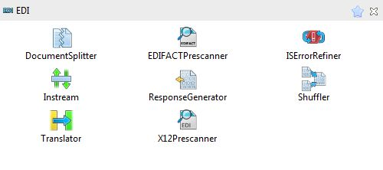

The following activities are available on your EDI integration project:

* [DocumentSplitter](https://docs.tibco.com/pub/bwpluginedi_healthcare/6.3.0/doc/html/GUID-24685921-59B9-46FA-A1BD-0522ECB09788.html)
* [EDIFACTPrescanner](https://docs.tibco.com/pub/bwpluginedi_healthcare/6.3.0/doc/html/GUID-9A738B71-4E19-4A7F-BA10-61DEF4E52B09.html)
* [ISErrorRefiner](https://docs.tibco.com/pub/bwpluginedi_healthcare/6.3.0/doc/html/GUID-85ABDF4E-350B-4C0B-89BD-545FC201AB81.html)
* [Instream](https://docs.tibco.com/pub/bwpluginedi_healthcare/6.3.0/doc/html/GUID-76CF699A-B997-4870-B4DF-20E6D1D697A1.html)
* [ResponseGenerator](https://docs.tibco.com/pub/bwpluginedi_healthcare/6.3.0/doc/html/GUID-D08F7975-4288-4440-9086-98D34A2F6014.html)
* [Shuffler](https://docs.tibco.com/pub/bwpluginedi_healthcare/6.3.0/doc/html/GUID-3521C9C8-7EC8-4483-A4CB-DF95347E406B.html)
* [Translator](https://docs.tibco.com/pub/bwpluginedi_healthcare/6.3.0/doc/html/GUID-6260E4BE-A724-42F6-A647-D92CFFDFEF1D.html)
* [X12Prescanner](https://docs.tibco.com/pub/bwpluginedi_healthcare/6.3.0/doc/html/GUID-E4E2D72A-726C-4A6F-BCD4-D653B9C1831D.html)

## Configuring Activities

When an activity has been added to the workspace, the activity can be configured by clicking on the activity icon.

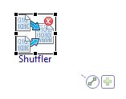

The properties view area below the workspace is populated with fields associated with the activity. Each activity has configuration tabs on the left, and a corresponding configuration input area on the right.

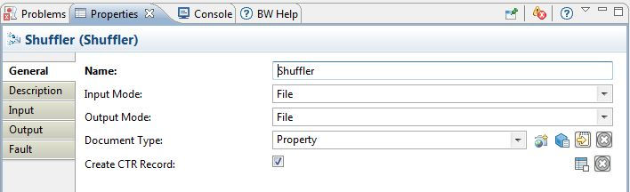

The configuration properties are grouped under tabs such as General, Description, Input, Output, and so on. For example, upon adding a Shuffler activity, you can configure it by specifying the values for the properties under the tabs General, Description, and Input, and view results using Output and Fault.

See Working with Standard Activity Features in the TIBCO ActiveMatrix BusinessWorks™ Application Development document for details.

**Configuration Using XPath**

Input, Output, Advanced, and Fault information is configured and displayed using the XPath Builder. XPath uses path expressions to navigate through XML documents. XPath also has basic manipulation functions for strings, numbers, and Booleans.

TIBCO ActiveMatrix BusinessWorks™ uses XPath as the language for defining conditions and transformations.

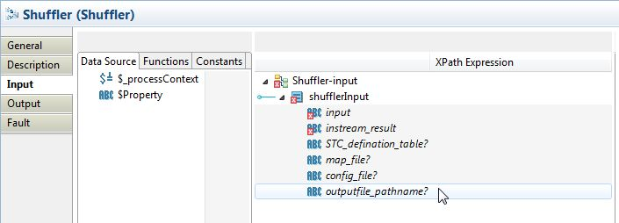

See XPath in the TIBCO ActiveMatrix BusinessWorks™ Application Development document for details.

Copyright © Cloud Software Group, Inc. All rights reserved.